✅ Rules and Best Practices for Interface Implementation

🔹 1️⃣ Naming Convention for Interface
It is common practice (not a rule) to prefix interface names with “I”.
Example:
interface IAccount {
}
This helps to visually differentiate between:
- Interface → IAccount
- Class → Account
However, many modern Java projects do not use I prefix.
They simply name it:
interface Account {
}
So using I is optional, not compulsory.

🔹 2️⃣ Naming Convention for Implementation Class
When a class implements an interface, a common naming practice is:
Interface Name + Impl
Example:
interface Account {
void withdraw();
}
Implementation class:
class AccountImpl implements Account {
public void withdraw() {
// logic
}
}
So:
- Interface → Account
- Implementation → AccountImpl
This is a convention, not a language rule.

🔹 3️⃣ “implements” Keyword
To implement an interface, we use:
class AccountImpl implements Account {
}
implements keyword tells Java:
This class is providing implementation for the interface contract.

🔹 4️⃣ A Class Must Implement All Interface Methods
If a class implements an interface:
interface Account {
void withdraw();
void deposit();
}
Then the implementing class must provide implementation for all methods:
class AccountImpl implements Account {

public void withdraw() {
}

public void deposit() {
}
}
If even one method is missing:
The class must be declared as abstract.
Example:
abstract class AccountImpl implements Account {
public void withdraw() {
}
}
Now child class must implement remaining methods.

🔹 5️⃣ If a Class Contains At Least One Abstract Method
If a class contains even one abstract method:
abstract class Bank {
abstract void withdraw();
}
Then the class must be declared as abstract.
Java enforces this rule.

🔹 6️⃣ Overriding Rules Must Be Followed
When implementing interface methods, overriding rules apply.
Important rule:
Visibility cannot be reduced.
In interface:
interface Account {
void withdraw();
}
This method is automatically:
public abstract void withdraw();
So when implementing:
class AccountImpl implements Account {

public void withdraw() {
}
}
You must write public.
If you write:
void withdraw() { }
It becomes default access.
Default is weaker than public.
Reducing visibility is not allowed in overriding.
So Java gives compile-time error.
That is why interface methods must be implemented as public.

🔹 7️⃣ If Methods Are Not Implemented
If a class does not implement all interface methods:
Then:
- The class must be declared abstract.
- The child class becomes responsible to implement remaining methods.
Example:
abstract class AccountImpl implements Account {
public void withdraw() {
}
}
Now subclass must implement deposit().

🔹 8️⃣ Interface Methods Must Be Implemented as Public
Whenever implementing interface methods:
They must be marked as public.
Otherwise:
Compile-time error will occur.
Because:
Interface methods are public by default.
And overriding cannot reduce visibility.

🔹 9️⃣ Important Missing Points (Very Important)
✔ A class can implement multiple interfaces
class A implements X, Y, Z {
}
Java allows multiple interface inheritance.

✔ Interface can extend another interface
interface A {
}

interface B extends A {
}

✔ A class can extend only one class
But it can implement many interfaces.
This is how Java achieves multiple inheritance behavior safely.

✔ Interface cannot have constructors
Because interface cannot be instantiated.

✔ Interface variables are always:
public static final
They behave like constants.
Eg: Interface_Eg1
// go though the code

Eg: Interface_Eg2
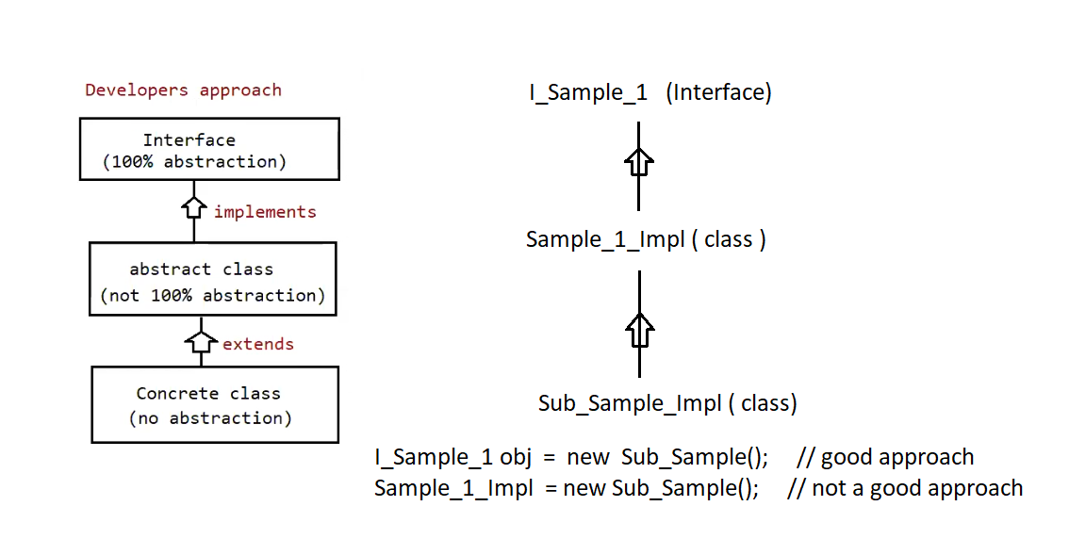

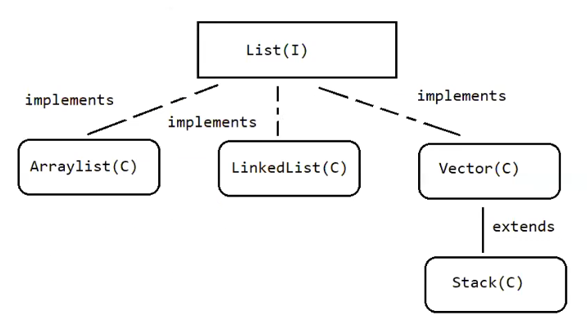

✅ Polymorphism with List Interface
From your diagram:
List (Interface)
/ | \
ArrayList LinkedList Vector
|
Stack
- ArrayList, LinkedList, and Vector implement List.
- Stack extends Vector.

🔹 Runtime Situation
At runtime, you may not know which object will come:
- ArrayList
- LinkedList
- Vector
- Stack
But you know one thing:
All of them implement the List interface.
So the correct approach is:
List ref = new ArrayList();
List ref = new LinkedList();
List ref = new Vector();
List ref = new Stack();
This is polymorphism.
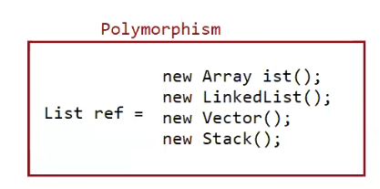

🔹 Why Reference Should Be Parent Type?
Because parent reference can hold any child object.
If you write:
ArrayList ref = new LinkedList(); // ❌ Not allowed
It gives compile-time error.
Why?
Because:
- ArrayList and LinkedList are siblings.
- One is not a parent of the other.
To avoid this problem:
Always use parent type reference.
Here parent is List.

✅ extends vs implements

🔹 extends (Class to Class)
One class can extend only one class.
Example:
class One {
}

class Two extends One {
}
Java does not allow:
class Three extends One, Two // ❌ Not allowed
Because Java does not support multiple inheritance with classes.

🔹 implements (Class to Interface)
One class can implement multiple interfaces.
Example:
interface One {
void methodOne();
}

interface Two {
void methodTwo();
}

class Demo implements One, Two {

public void methodOne() {
}

public void methodTwo() {
}
}
Java allows multiple interface implementation.

✅ Case 2: Class Extending + Implementing
A class can:
- Extend one class
- Implement multiple interfaces
Example:
interface One {
void methodOne();
}

interface Two {
void methodTwo();
}

class Base {
}

class Demo extends Base implements One, Two {

@Override
public void methodOne() {
// implementation
}

@Override
public void methodTwo() {
// implementation
}
}
Important Rule:
extends must come first
implements must come after extends
Correct syntax:
class Demo extends Base implements One, Two

🔹 Why extends Comes First?
Because:
- Class inheritance defines base behavior.
- Interface implementation defines contract.
Java syntax rule:
class Child extends Parent implements Interface1, Interface2

✅ Reusability Concept
When writing applications:
First priority → reuse existing class (extends).
If needed functionality is not available in class hierarchy:
Then → use interface (contract) and provide implementation.
That is why syntax follows:
extends first → implements next

✅ Interface Relationships
Here are the valid combinations:
Relationship | Keyword
class & class | extends
class & interface | implements
class extends class & implements interface | extends + implements
interface & interface | extends

🔹 Why Interface Uses "extends"?
Because:
- Interface cannot give full implementation.
- It only declares methods (contract).
- So one interface can extend another interface.
Example:
interface One {
void methodOne();
}

interface Two {
void methodTwo();
}

interface Three extends One, Two {
void methodThree();
}
Important:
Interface can extend multiple interfaces.
This is allowed.

✅ Case 3: Interface Extending Multiple Interfaces
Example:
interface One {
void methodOne();
}

interface Two {
void methodTwo();
}

interface Three extends One, Two {
void methodThree();
}
Now:
Three contains:
- methodOne()
- methodTwo()
- methodThree()
Because it inherits methods from One and Two.

Implementing Class
class SampleImpl implements Three {

public void methodOne() {
}

public void methodTwo() {
}

public void methodThree() {
}
}
Since SampleImpl implements Three, it must implement:
- methodOne()
- methodTwo()
- methodThree()
Because methods from One and Two are now part of Three.

